Brief Report

1. Quarter Selection

This analysis focuses on Q2 2025 (April to June), a quarter chosen for its distinctive seasonal dynamics. Unlike the relatively flat demand of Q1, spring brings a rapid ridership build-up driven by warming temperatures, the end of university semesters, and increased recreational cycling. Q2 also coincides with Indego's 10th anniversary celebrations in late April, which introduced short-term demand spikes not captured by routine time and weather variables. These characteristics make Q2 particularly challenging and interesting to model: demand is higher on average, more variable day-to-day, and more sensitive to factors beyond the standard commute cycle. A model that performs well under these conditions would be genuinely useful for spring rebalancing operations.
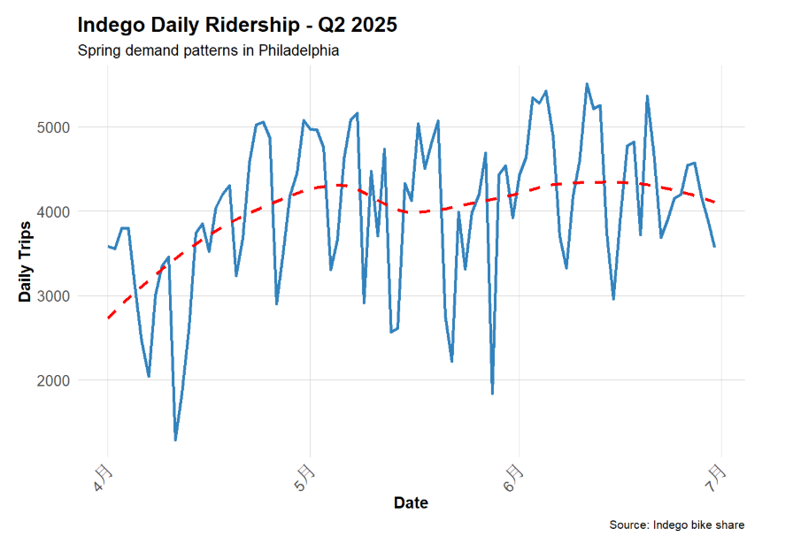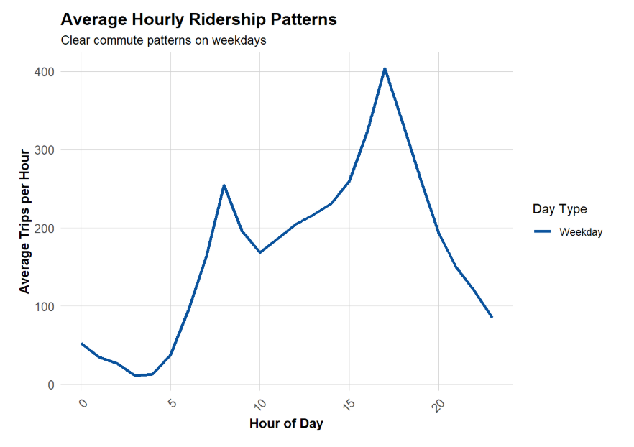

2. Model Comparison

Five models were estimated, each adding a layer of predictors. Model 1 (time and weather only) produced an MAE of approximately 0.85 rides per station-hour. Adding temporal lag variables in Model 2 reduced MAE substantially to around 0.69, the single largest gain across all models. Models 3 through 5, which added demographics, station fixed effects, and a rush-hour interaction term, produced negligible further improvement, all clustering near 0.69 MAE. This pattern confirms that temporal lag is the dominant predictive signal: knowing what demand was one hour, three hours, and twelve hours ago explains most of what can be explained. Compared to Q1 2025 (0.53), Q2 exhibits higher MAE (0.68) but also higher R² (Q1 = 0.27, Q2 = 0.35).
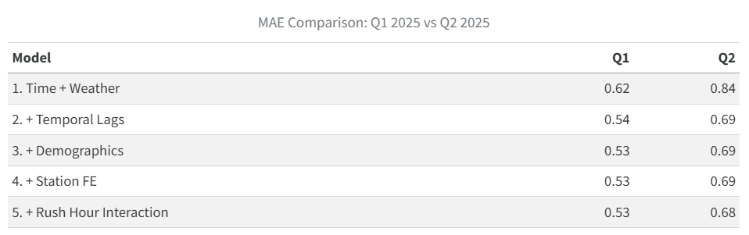
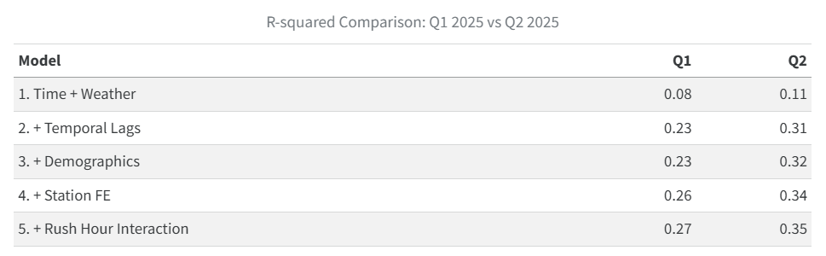
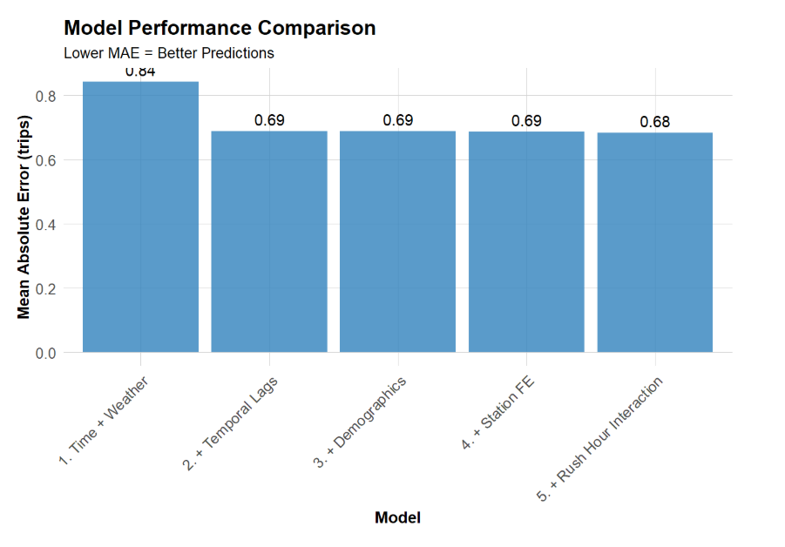

3. Error Analysis

Temporal error patterns reveal that PM Rush hours carry the highest MAE (approximately 1.0), followed by weekend midday periods. Overnight hours are predicted most accurately, with MAE near 0.31. This gap reflects a fundamental model limitation: temporal lags capture routine periodicity well, but surge events during peak commute windows—when small incidents can cause disproportionate ridership spikes.

Spatially, prediction errors cluster in Center City and along the Schuylkill waterfront trail—Philadelphia's highest-demand areas. This is not a demographic finding; it reflects density
effect. High-volume stations have more variance to predict, and the model's systematic under-prediction of peak spikes produces larger absolute errors precisely where ridership is greatest.

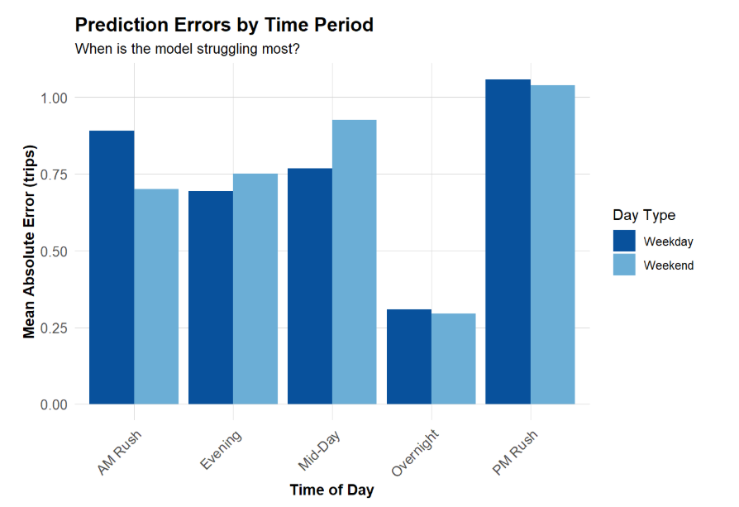
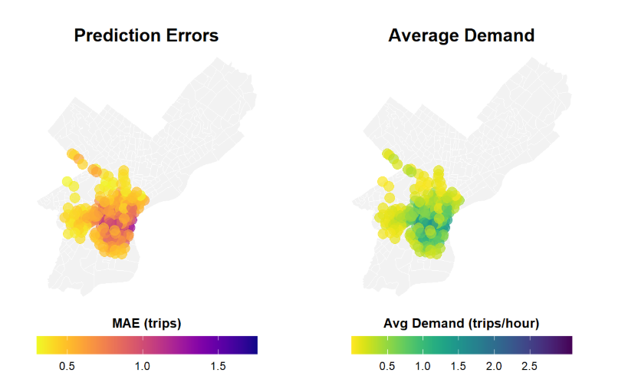
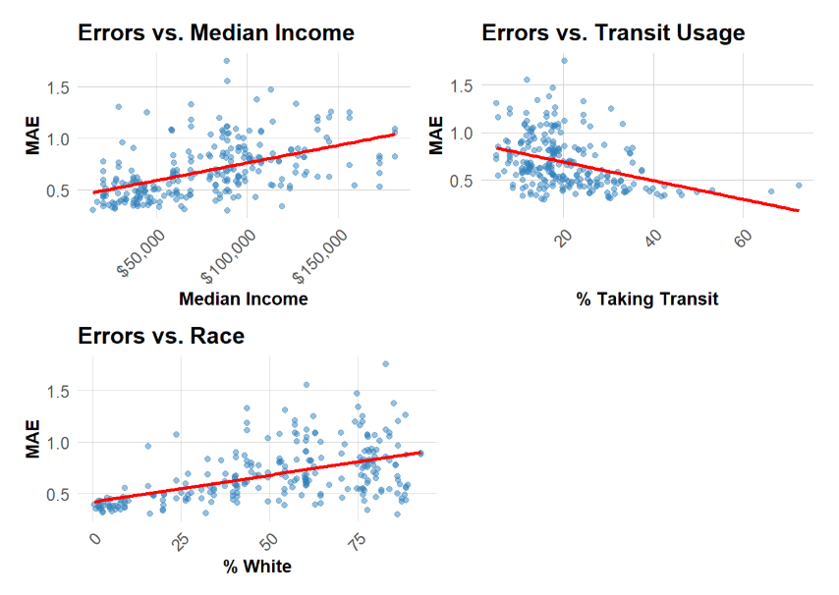
The demographic error pattern is counterintuitive: errors are highest in majority-white, high-income census tracts, again because those tracts contain Center City's dense station clusters. The more meaningful equity concern is not prediction accuracy but station scarcity: low-income neighborhoods receive fewer stations, generating less training data and making model-guided rebalancing decisions inherently biased toward already well-served areas.

4. Feature Engineering

Three new features were engineered based directly on the error analysis findings. First, a binary perfect_weather indicator (temperature 60–75°F, zero precipitation) was constructed to capture the leisure cycling demand spikes that appeared most prominently in Center City's spatial error clusters—the stations where pleasant weather converts latent demand into actual trips. Second, a lag7day variable was added, capturing demand exactly 168 hours prior, to address the weekly periodicity that the standard 1-hour and 24-hour lags cannot represent. Third, a rolling7day average of the prior 168 hours was included to smooth out gradual April-to-May demand build-up that appears as persistent under-prediction in the temporal error chart.

Together, these features reduced MAE from 0.6885 (Model 5) to 0.6743 (Model 6), while R² improved from 0.345 to 0.362. The gains are modest but theoretically grounded: each feature addresses a specific failure mode identified in the error analysis rather than being added speculatively.
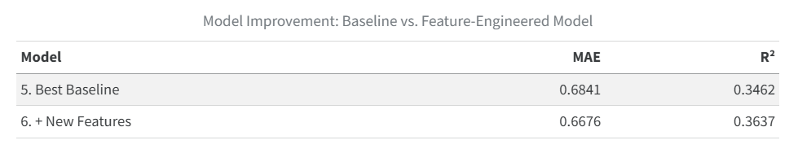

5. Critical Reflection

Despite incremental improvements, the final model's MAE of 0.67 rides per station-hour is insufficient for automated operational deployment. During PM Rush hours—the period when accurate prediction matters most for rebalancing decisions—MAE exceeds 0.9. A system acting on these predictions would systematically mis-allocate bikes precisely when demand is highest. The appropriate use case is a decision-support tool that surfaces predictions to human operators who retain authority to override, not an automated dispatch system.

The equity implications are more serious. By design, this model optimizes prediction accuracy for the stations with the most historical data. Those stations are concentrated in high-income Center City neighborhoods where ridership is already high. Low-income areas appear in the training data primarily as low-demand stations—not because cycling demand is absent, but because station scarcity suppresses observed ridership. A model trained on this supply-constrained data will perpetuate under-investment in underserved communities, creating a feedback loop where predicted low demand justifies the low supply that produced the low demand in the first place.

Additional limitations include the model's assumption that historical demand patterns are stable—an assumption violated by Indego's expansion, weather anomalies, and major events. The model contains no event feeds, no POI proximity data, and no information about nearby construction or transit disruptions. It treats all stations with the same functional form, despite substantial heterogeneity between commuter hubs, residential stations, and tourist-adjacent locations. These constraints suggest that the next modeling iteration should incorporate external data sources and consider station-type stratification before any operational deployment is considered.

